2022 Historic Foodways Society of the Delaware Valley
Membership Application/Renewal

Celebrating and Learning about food history for over 25 years!

Dues are $20, per CALENDAR Year
We do not do rolling renewals. Annual dues cover Jan. 1 to Dec. 31st
- All Renewals are due each year by February 28th

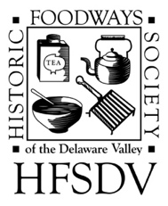

Checks should be made out to HFSDV and mailed along with this form to:
Cindy Faulkner
HFSDV Treasurer
435 Bayard Road
Kennett Square, Pa. 19348

All virtual programs for 2022 are free to members

I would like to join or renew by Membership in the
Historic Foodways Society of the Delaware Valley

Name______________________________________________________________________

Address____________________________________________________________________

City_________________________ State _____________ Zip Code ____________________

Phone______________________________ Cell Phone ______________________________

E-mail Address ______________________________________________________________

Site/Organization Affiliation ____________________________________________________

May we include your contact information distributed to members only?
Yes ________________ No _______________

If you have a personal or site web site that may be published in the directory and on the HFSDV website? Please list: Web Address________________________________________________

Let us know if there is any particular topic/period you are interested in:
____________________________________________________________________________

