Recipe for Subversion:
How Suffragists Used Cookbooks to Fight for the Vote
Virtual presentation August 8, 2020

Suffrage Cookbook Recipes

Compiled by Dan Macey, president of the Historic Foodways Society of the Delaware Valley, www.historicfoodways.org dantasticfood, www.dantasticfood.com
Dan@dantasticfood.com

Suffrage Cake
Daily Oklahoman, Aug. 3, 1916

Two eggs,
One cup sugar,
One-half cup milk,
One and one-half cups flour,
One tablespoon melted butter,
Two tablespoons baking powder,
One tablespoon orange juice,
One teaspoon grated rind (of an orange),
Beat eggs well and add the sugar, melted butter, orange juice, grated rind, flour and baking powder. Sift flour and baking powder four times.
Bake in a square pan, split fill with orange cream.

Dantasticfood’s modern twist on the cake
Dantasticfood’s Orange Suffrage Cake
2 ½ cups Bisquick
2/3 cups sugar
¼ cup melted butter
3 eggs
¾ cups milk 1 teaspoon vanilla
4 tablespoons grated orange rind, divided
1 11-ounce can mandarin oranges, drained
3 cups of whipped cream (you can use whipped topping if you prefer)
(if you use whipped cream, you must refrigerate the cake)
½ cup orange marmalade

1. Preheat oven to 325 degrees.
2. Combine the Bisquick, sugar, melted butter, eggs, milk, grated orange rinds in a large bowl and whisk together until all the ingredients are well combined, about 4 minutes.
3. Spray a square 8”x8” cake pan with cooking spray. Add the batter and bake at 325 degrees for 40 minutes. Allow to cool in the pan for 5 minutes, then allow to cool completely on a cooking rack.
4. Cut cake in half horizontally. Spread ¼ cup of the orange marmalade on the first layer. Spread 1 cup of whipped cream on top and sprinkle with half of the mandarin oranges.
5. Carefully place the second layer of the cake on top of the first one. Spread the remaining orange marmalade on top. Top with the remaining 2 cups of whipped cream. Decorate with the remaining mandarin oranges. Grate 1 tablespoon of the orange rind over the cake.

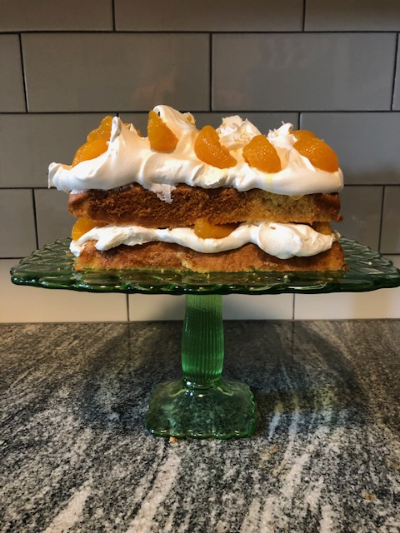

***

The “famous” Suffrage Angle Cake in the Suffrage Cook Book,
Good luck with making this!

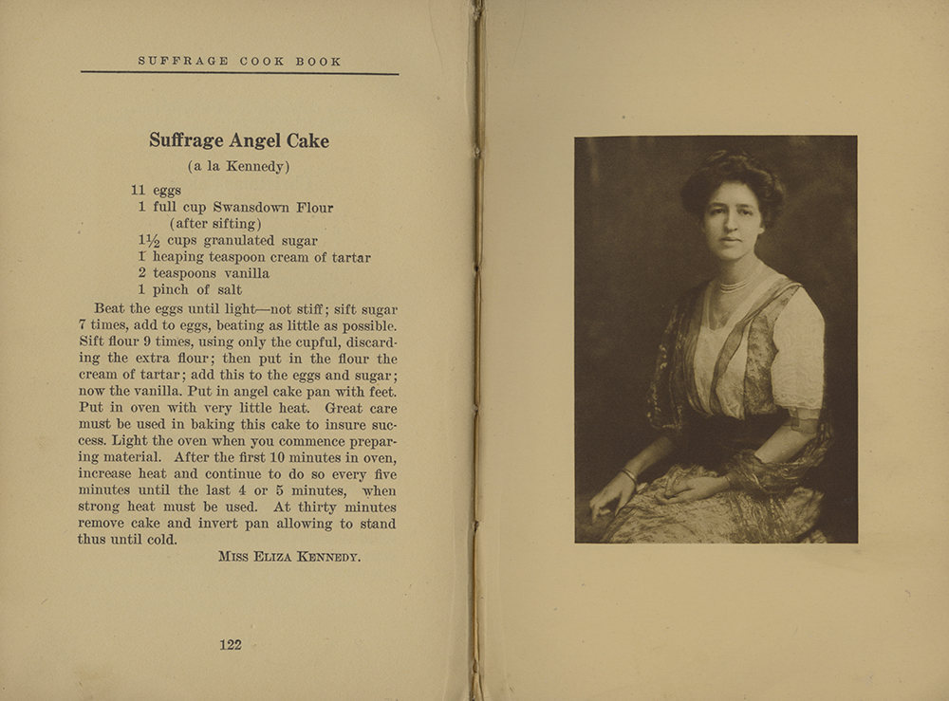

***

Suffrage Cookkies
From L.O. Kleber, as published in the Pittsburgh Press, Sept. 13, 1911 (but not contained in The Suffrage Cook Book)

2 cups flour
1 orange
Half cup butter
Half cup sugar
Peel the orange and grate the skin into the flour. Cream the butter and sugar. Stir all together, with enough water to make dough of the right consistency and bake until crisp. Sprinkle with sugar.

***
Iowa’s Suffrage Fruit Cake

This is the information about an Iowa suffrage fruit cake
Made by Mrs. Pleasant J. Mills.

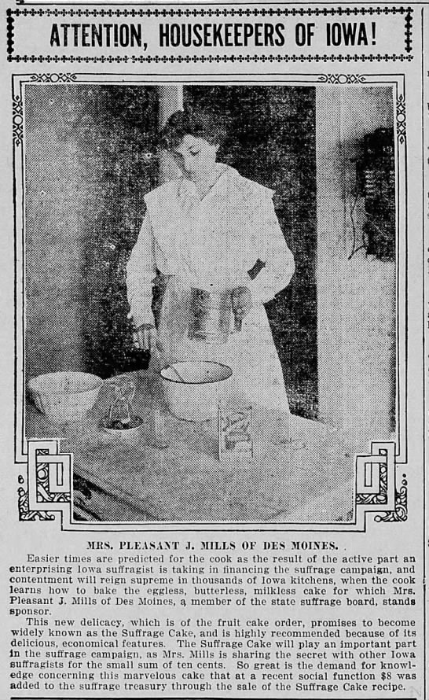

This cake was hailed in the April 3, 1916 issue of the Des Moines Tribune
As “a telling refutation to the assertion by those who do not know that suffragists cannot cook.”
And was said to be “eggless, butterless, milkless and peerless (unrivaled)”
I could not find Pleasant Mills actual recipe.

So, here is a recipe I found for an Eggless-Milkless-Butterless Cake
From the Taste of Home website and received a 4-star review.
This cake was later sometimes called “Wartime” Cake since it didn’t require the use of many rations.
I think it is probably close to what Mrs. Mills’ cake was like.

1 cup packed brown sugar
1 cup water
1cup raisins
1/3 cup shortening
1 teaspoon ground cinnamon
½ teaspoon ground cloves
¼ teaspoon ground nutmeg
2 cups all-purpose flour
1 teaspoon baking powder
1 teaspoon baking soda
½ teaspoon salt

1. In a heavy saucepan, combine the first 7 ingredients. Bring to a boil. Cook for 5 minutes, stirring occasionally. Cool to room temperature.
In a large bowl, combine the flour, baking powder, baking soda and salt; add the raisin mixture. Pour into a greased 9x5” loaf pan.
3. Bake at 350 degrees for 45-50 minutes or until a toothpick in the center comes out clean. Cool for 10 minutes before removing from pan to a wire rack. Serve with hard sauce if desired.

***

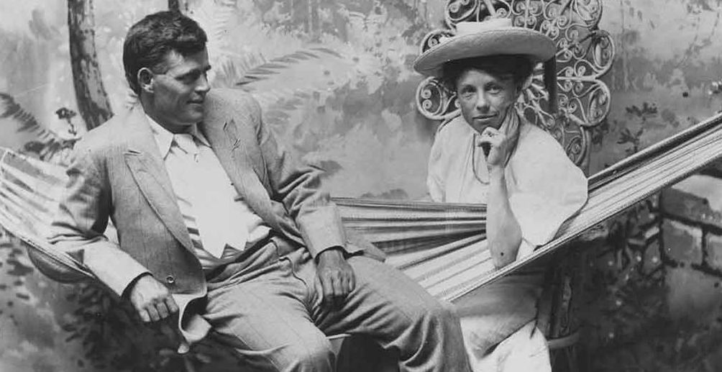
Author Jack London with Author and Suffragist Charlotte Perkins Gilman
Jack London, author most famous for Call of the Wild, met writer Charlotte Perkins Gilman, a vocal supporter of the women’s suffrage movement, in California. The two shared an interest in socialism, and London contributed a recipes to The Suffrage Cook Book. London died a year after the cookbook’s publication, three years before women’s suffrage became a reality in 1920.
Stuffed Celery
A most delicious relish is made with Roquefort cheese, the size of a walnut, rubbed in with equal quantity of butter, moistened with sherry (lemon juice will serve if sherry be not available), and seasoned with salt, pepper, celery salt and paprika; then squeezed into the troughs of a dozen slender, succulent sticks of celery. This is a very appropriate prelude to a dinner of roast duck.
***

Cottage Cheese
From The Suffrage Cook Book

To make cottage cheese effectively, with an aroma and delicacy equal to its nourishment, a rich milk which has not lost time in souring should be put in an earthenware or stone jar with the lid on, and placed in hot water over a very slow fire until it is well heated with the curd clotted from the whey. When it begins to steam the curd is drained a very short period through cheese cloth. Well mixed with salt and butter and pepper it is an ideal muscle and tissue maker.

Cottage cheese is much more easily turned into brawn, brain and bone than any of the les porous, less ripe cheeses. I fact the curious uncomfortable bloated sensation experienced by many who eat other variety of cheese is uncommon with cottage cheese.

Faulty mastication, peculiar susceptibilities to casein and an excess of other solid foods often causes the distress which follows cheese eating. If well emulsified with saliva by the teeth or mixed with water and not gulped down, cottage cheese serves every sort of food purpose.

***
From Karo Syrup’s For Better Baking, Votes for Women pamphlet, 1913

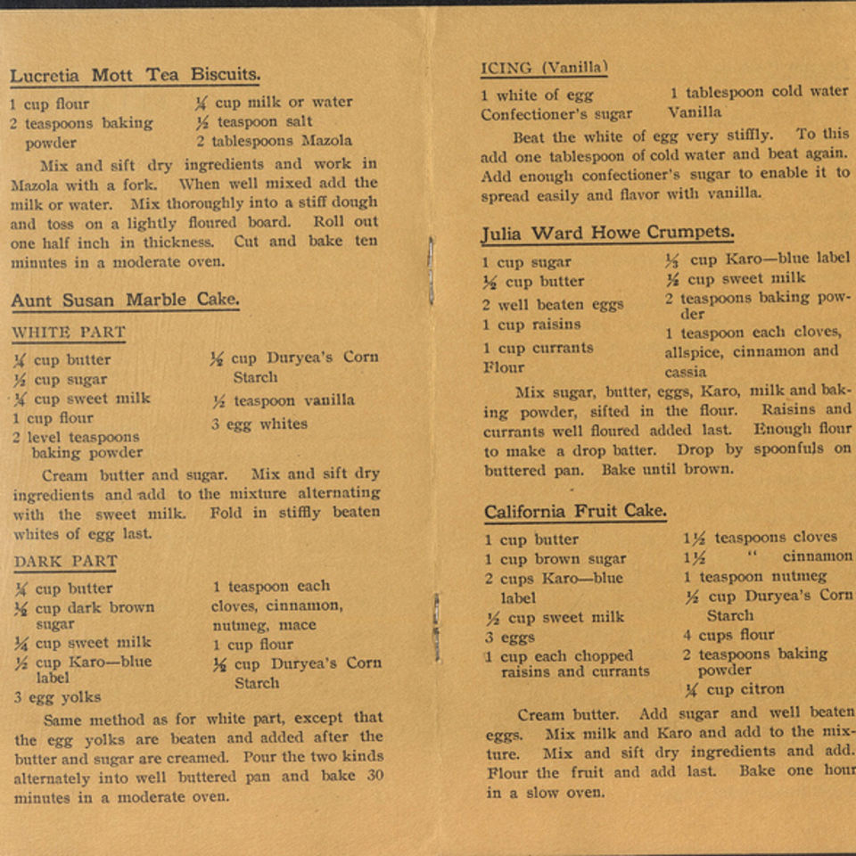

***

An finally, a great page – a recipe -- from the Suffrage Cook Book

